
Computer Organization And Assembly language
BSCS-4-C

IQRA Jahangir
21805

Question 01:
Part a:
For a grading calculator, the program:
- Stores the student's average marks
- Compares the average with grade boundaries
- Uses conditional jumps to move to the correct grade label
The grading calculator mainly uses these jumps:
JGE → Jump if Greater or Equal:
Transfers control to another label if the first value is greater than OR equal to the second value.
JL → Jump if Less:
Transfers control if the first value is less than the second value.
JMP → Unconditional Jump
Always jumps to another label. No condition checking.
These jumps work after the CMP instruction.
Code:

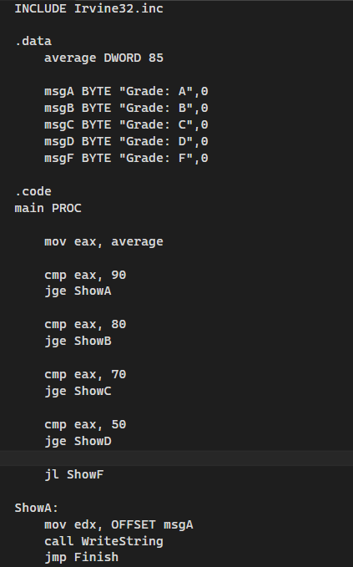
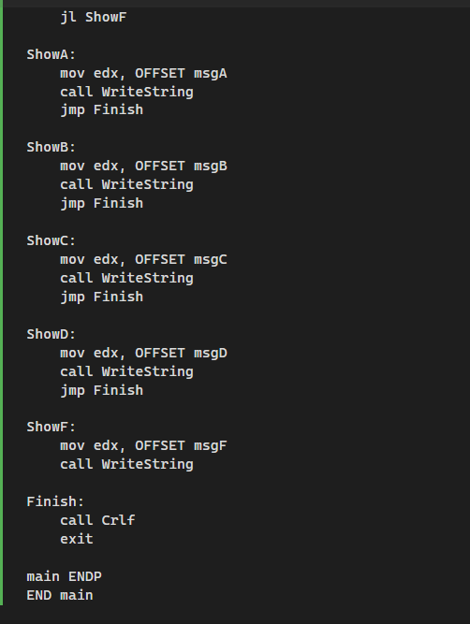
Output:
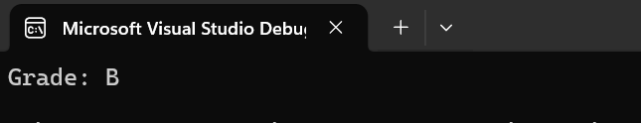

Part b:
The Overflow Flag (OF) is set when the signed result of an arithmetic operation becomes too large or too small to fit in the destination register.
The Carry Flag (CF) is set when there is a carry out (for addition) or borrow (for subtraction) in unsigned arithmetic.
This program demonstrates:
- Addition that sets Overflow Flag
- Addition that clears Overflow Flag
- Subtraction that sets Overflow Flag
- Subtraction that clears Overflow Flag
- Addition that sets BOTH Carry and Overflow Flags
Code:
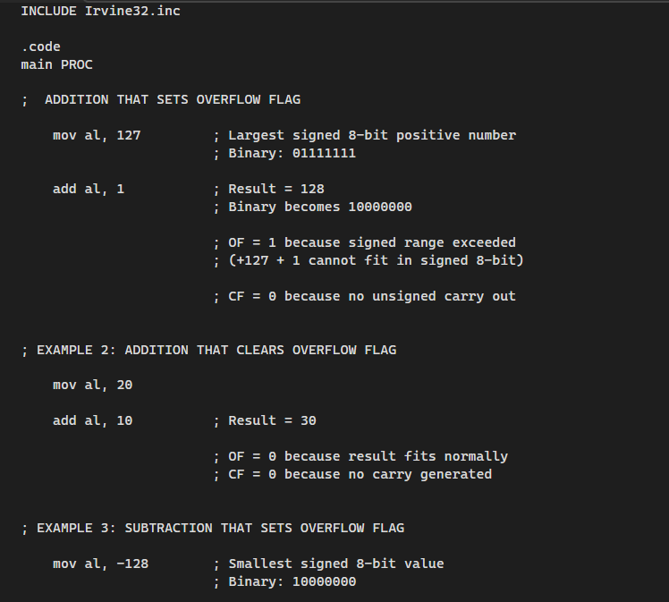
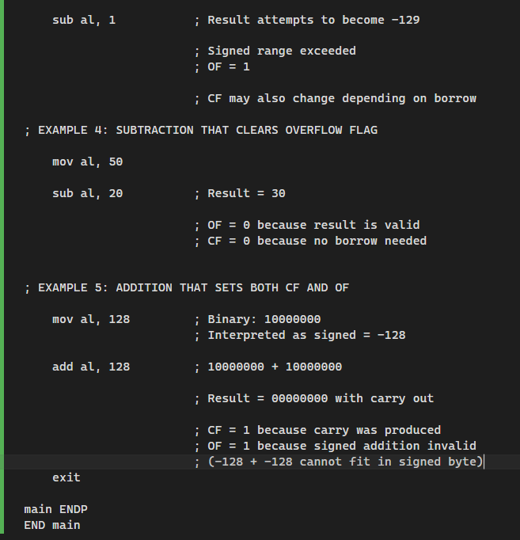
Overflow Flag is mainly for SIGNED arithmetic. Signed 8-bit range is -128 to +127. If result exceeds this range:
- OF becomes 1
Carry Flag is mainly for UNSIGNED arithmetic. For 8-bit unsigned numbers 0 to 255.If result exceeds 255:
- CF becomes 1

Part c:
Decreasing Numeric Pattern Using Procedure and Parameter Passing:
Code:

This program in Microsoft Macro Assembler demonstrates:
- Procedures
- Parameter passing
- Nested loops
- Number pattern generation
The procedure PrintPattern receives a parameter N from the main procedure and prints a decreasing numeric pattern.
Code:
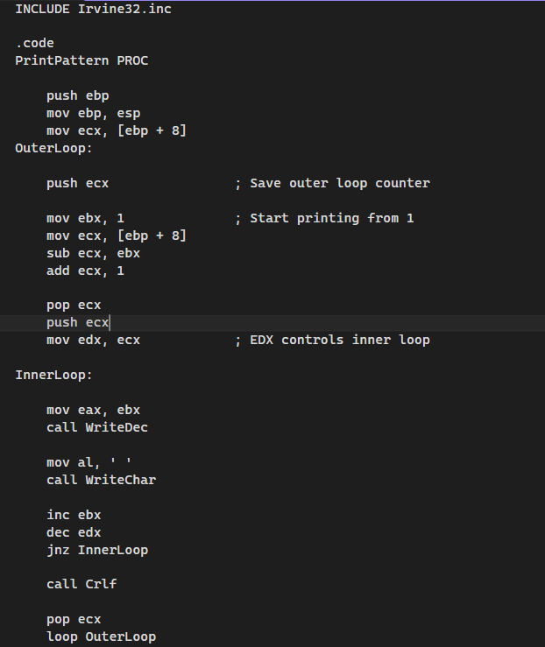
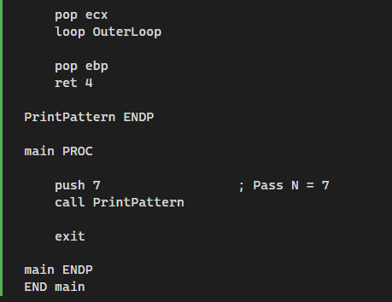
Output:
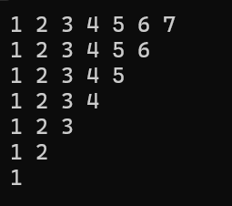
This program demonstrates how assembly language:
- breaks problems into procedures
- uses stack-based parameter passing
- controls repetition using nested loops
- generates dynamic output patterns based on input value N
Question 02:
This program in Microsoft Macro Assembler demonstrates:
- Character input processing
- ASCII conversion
- Loops
- Conditional jumps
- Procedures
- Even/Odd checking using bitwise AND
The program:
- Accepts 3 characters
- Converts uppercase letters to lowercase
- Displays each character on a new line
- Accepts a security code integer
- Determines whether the code is EVEN or ODD

Code:
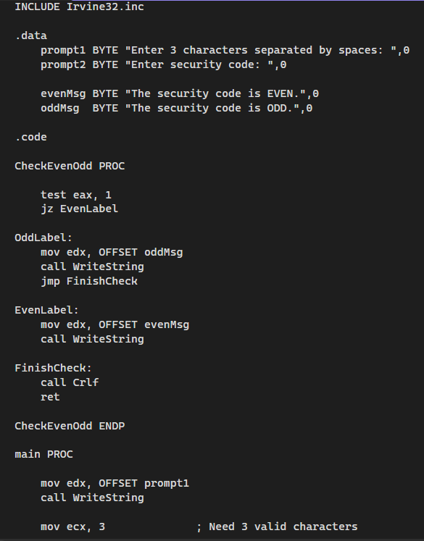
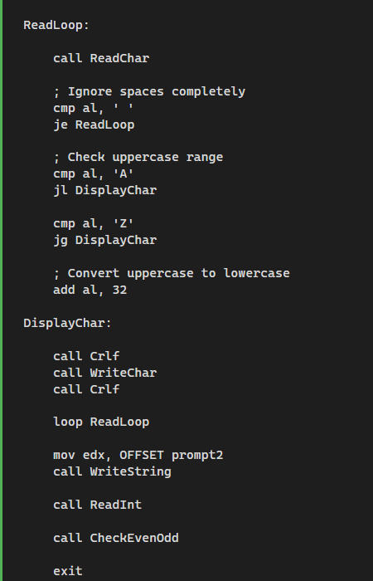
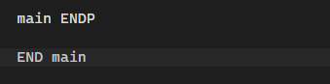
Output:
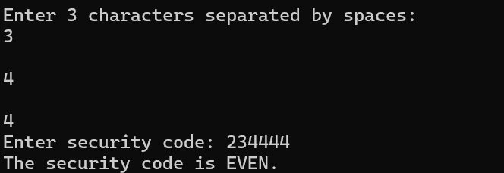
- This program in Microsoft Macro Assembler works as a simple secure input utility that performs both character identity processing and security code verification. The .data section stores all prompts and output messages, while the .code section contains the executable instructions. Execution begins in main PROC, which controls the overall flow of the program.
- First, the program displays a message asking the user to enter three characters separated by spaces. The ReadLoop uses the ECX register as a loop counter to ensure that exactly three valid characters are processed.
- Inside the loop, ReadChar reads one character at a time into the AL register. The CMP instruction along with conditional jumps such as JE, JL, and JG checks whether the input is a space or an uppercase letter between A and Z. If the character is uppercase, ADD AL,32 converts it into lowercase using ASCII conversion logic; otherwise, the character remains unchanged.
- WriteChar then displays each processed character on a new line. After processing the characters, the program asks the user to enter an integer security code using ReadInt, which stores the number in the EAX register.
- The CheckEvenOdd procedure is then called to determine whether the number is even or odd. Inside this procedure, the TEST EAX,1 instruction checks the least significant bit of the number. If the result is zero, the JZ instruction jumps to the even-number section; otherwise, the odd-number message is displayed. Finally, the program outputs the appropriate message and terminates using the exit instruction.

